**Noise in Digital Signals**

**Sources of Noise**

Noise = Disturbances that are unwanted/unrelated in a digital signal e.g(sudden spikes,…)

*Random noise* **vs** *systematic error*

* Random noise is **stochastic**
* Quantization error
* Sampling jitter
* Thermal effect in electronics
* Interference from other signals
* System noise is **deterministic**
* Measurement offset
* Non-linear response
* Generally, can be calibrated

Stochastic = randomly determined process in a System

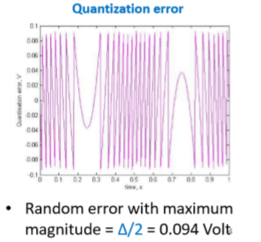Deterministic = System in which no randomness occurs

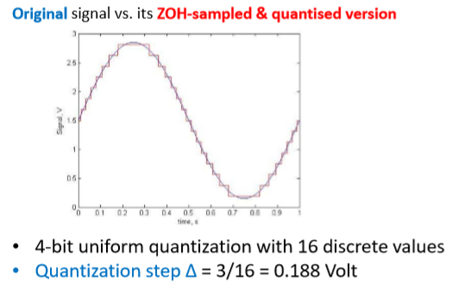

**Quantization Error**

Quantization = maps a sample value to one of the possible discrete values

*Quantization Step*:

Δ = (Vmax - Vmin)/ 2N

*Quantization Error*:

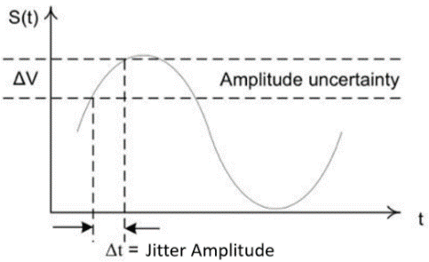Δerror = Δ / 2

**Sampling Jitter**

Sampling Jitter = the time between **samples** varies causes = Sampling Amplitude uncertainty

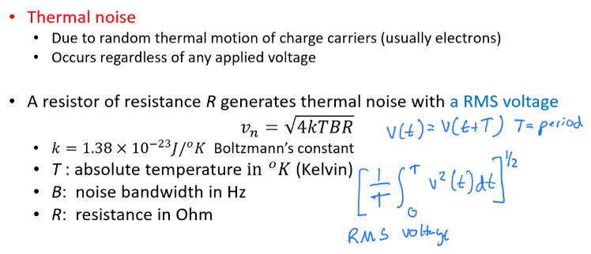Example: For a sinewave with amplitude A and frequency f Hz, maximum error magnitude is ∆𝑉 = 2𝜋𝑓𝐴∆𝑡

Derivation: 𝐴𝑠𝑖𝑛 2𝜋𝑓𝑡 has an instantaneous/ocurring changing rate of 2𝜋𝑓𝐴𝑐𝑜𝑠 2𝜋𝑓𝑡 . Hence Maximum amplitude change after sampling jitter is 2𝜋𝑓𝐴𝑐𝑜𝑠 2𝜋𝑓𝑡, ∆𝑡 ≤ 2𝜋𝑓𝐴∆𝑡

**Johnson Noise**

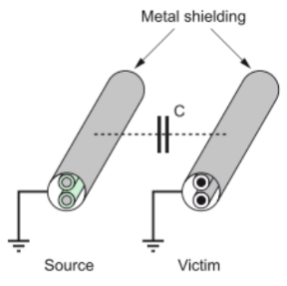**Interference**

**Conductive coupling**

3 sources of interference that could be present simultaneously

* **Conductive** coupling: noise current caused by a changing voltage in a nearby circuit
* When two parallel wires act like a capacitor
* 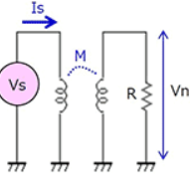**Inductive** coupling: noise voltage caused by a changing current in a nearby circuit

**Inductive** **coupling**

Two inductors in parallel creates a magnetic field

* **Resistive** coupling: occurs when high-level signals share a wire with low-level signals

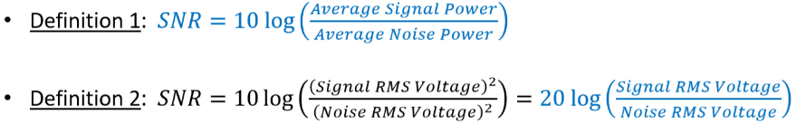**Signal-to-Noise Ratio (SNR)**

Expressed in decibel (dB)

* 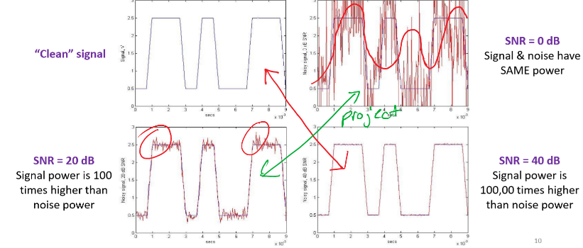Logarithm used to better quantify very large or small values such as SNR
* SNR = 0 dB Signal & noise have SAME power
* We want to have SNR = 20 dB

b = 10 (base)

1. bx­­­­­­­ = y
2. logb(y) = x

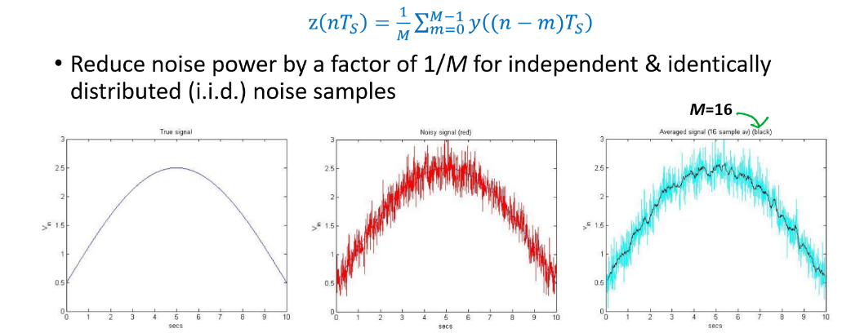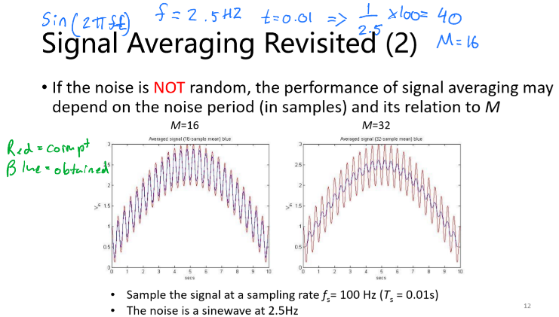**Signal Averaging**

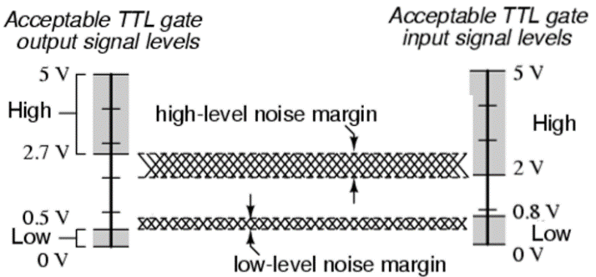

We See that by increasing M, we get a closer approximation to the true signal.

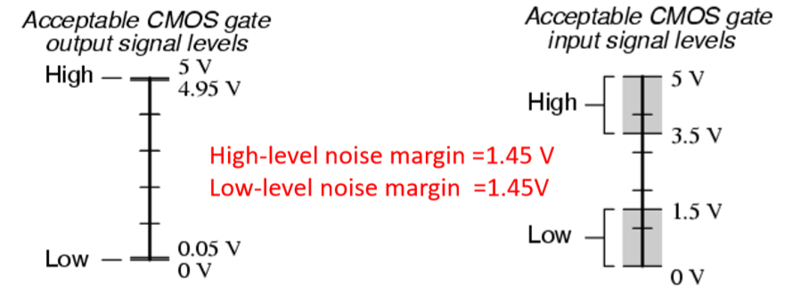**Noise Margin** Ideal voltages are rarely attained in practice TTL = transistor-transistor logic CMOS = Complementary metal–oxide–semiconductor

Noise margins in TTL:

* High-level = 2.7 – 2 = 0.7 V
* Low-level = 0.8 – 0.5 = 0.3 V

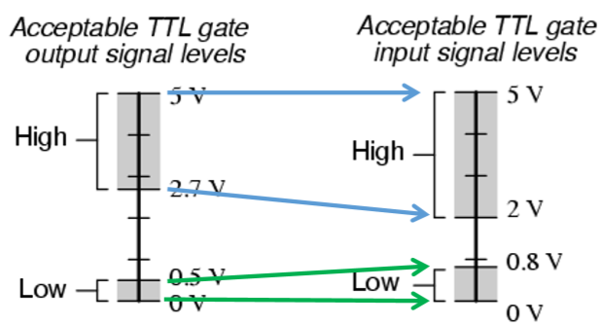**Hardware Interfacing**

Compatible = TTL output to TTL input

Compatible ->

Incompatible = uncertain response at CMOS gate when TTL is HIGH (can’t use TTL with CMOS)

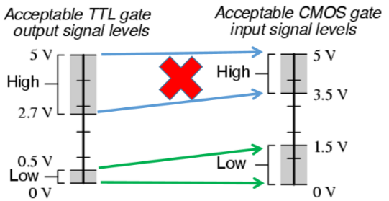

<- Incompatible